# **DATA INTERPRETATION**

## **DOMAIN ANALYSIS:**

**Employee Demographics**:

Includes **EmpNumber**, **Age**, **Gender**, **EducationBackground**, **MaritalStatus**. These fields help in understanding the diversity and background of the workforce.

**Departmental Data**:

**EmpDepartment** and **EmpJobRole** indicate the department and specific roles of the employees, crucial for analyzing department-specific performance.

**Work-related Details:**

**BusinessTravelFrequency** and **DistanceFromHome** could affect employee satisfaction and performance.

**EmpEducationLevel**, **EmpEnvironmentSatisfaction**, **EmpHourlyRate**, **EmpJobInvolvement, EmpJobLevel, EmpJobSatisfaction** provide insights into the educational background and job satisfaction levels which are directly linked to performance.

**Performance Metrics:**

**PerformanceRating** is the key outcome variable. Other related metrics include **YearsSinceLastPromotion, YearsWithCurrManager, and ExperienceYearsAtThisCompany,** which help in understanding career progression and its impact on performance.

**Additional Attributes:**

**OverTime** and **Attrition** indicate work-life balance and employee retention, respectively, which are critical for organizational health.

# **SUMMARY OF IMPORTANT ASPECTS OF THE MODEL**

## **DATA ANALYSIS**

### **VISUALIZATION**

To effectively explain analysis findings, we used visualisations such as **histograms, count plots, pie charts, box plots, pair plots, and heatmaps**. Data visualisations can help make intricate relationships and patterns easier to see and comprehend.

#### **UNIVARIATE ANALYSIS:**

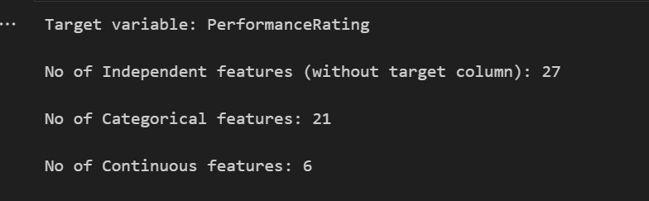

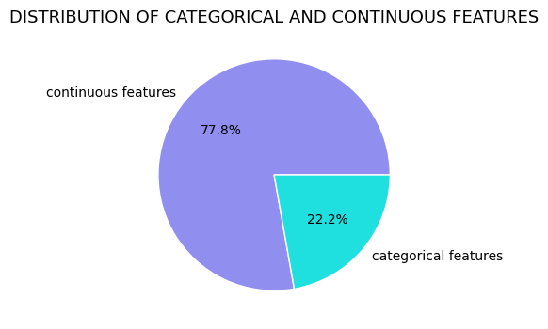

**Discrete features:**

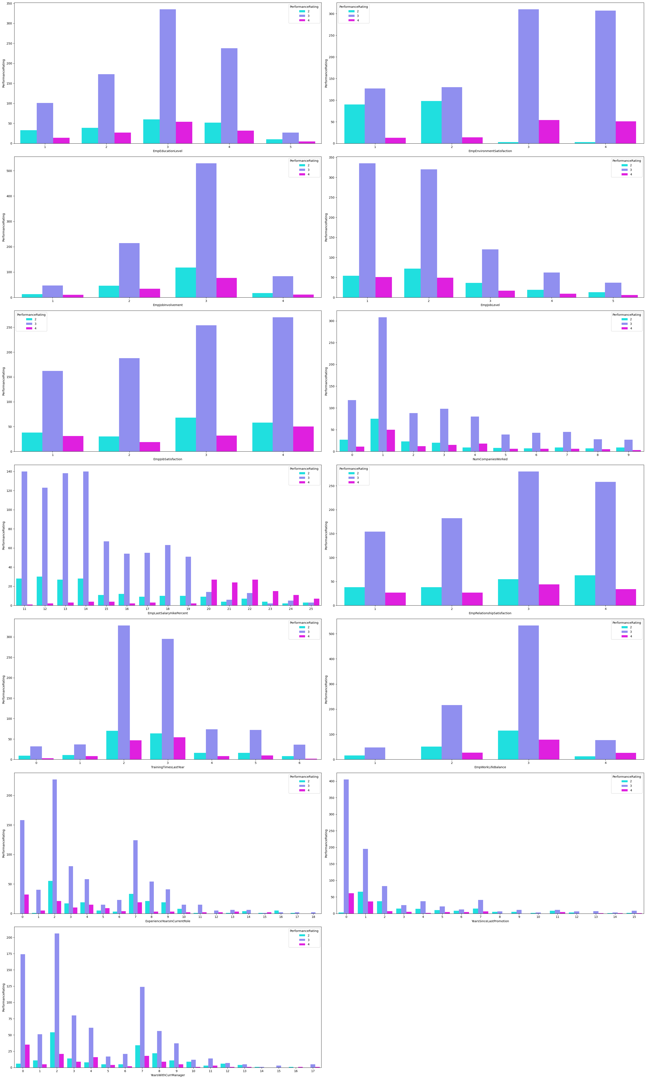

**Categorial features:**

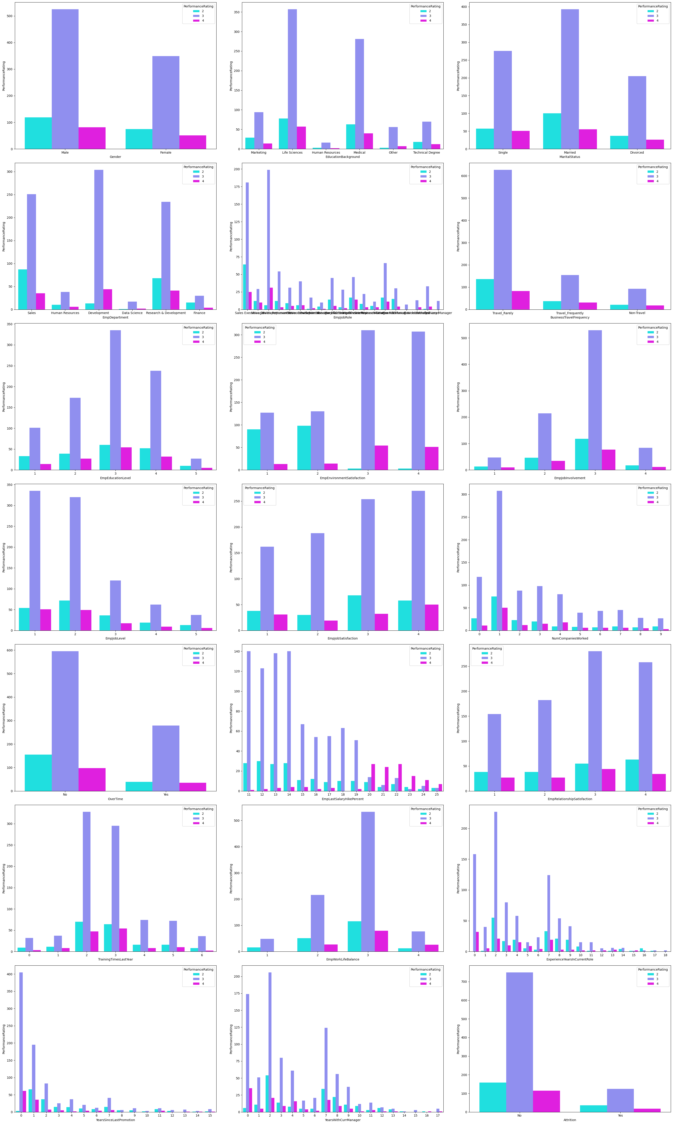

**Continuous features:**

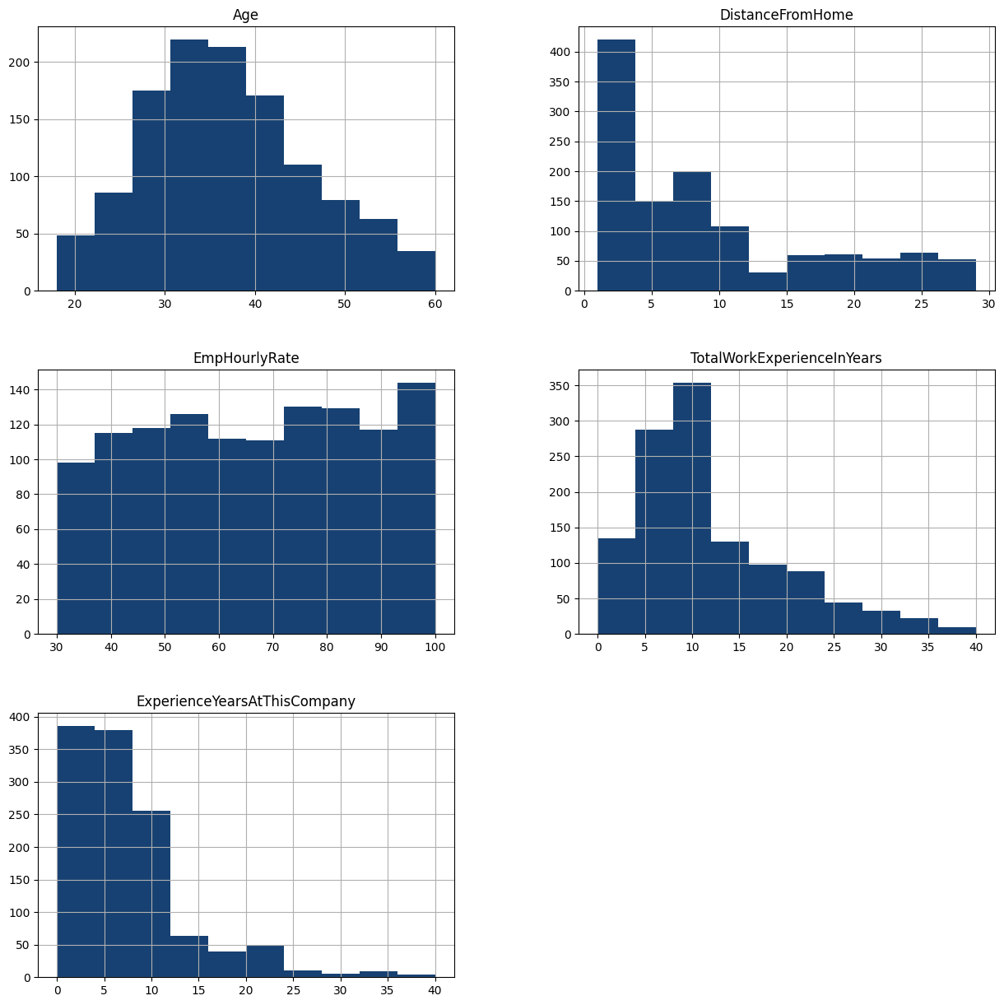

**Insights from univariate analysis:**

* **Gender**: The distribution of performance ratings across genders can reveal if there is a gender bias in performance evaluations.
* **EducationBackground**: Understanding how employees from different educational backgrounds are rated can help in assessing if educational diversity impacts performance perceptions.
* **MaritalStatus**: This plot can show if marital status influences stability and performance ratings, potentially indicating if personal life stability translates into professional performance.
* **EmpDepartment**: Different departments might have varying benchmarks for performance ratings. This plot helps in identifying if certain departments rate their employees more stringently or leniently.
* **EmpJobRole**: Similar to departments, this can show if specific job roles are associated with higher or lower performance ratings, which might reflect on the expectations and pressures associated with those roles.
* **BusinessTravelFrequency**: Employees who travel more or less frequently might experience different stress levels and work challenges, which could affect their performance ratings.
* **EmpEducationLevel**, **EmpEnvironmentSatisfaction**, **EmpJobInvolvement**, **EmpJobLevel**, **EmpJobSatisfaction**: These plots can highlight how intrinsic job factors and personal employee satisfaction levels correlate with performance ratings.
* **NumCompaniesWorked**: Insights from this plot can indicate if having experience in multiple companies affects performance positively or negatively.
* **OverTime**: Overworking can either be seen as a sign of dedication or a route to burnout. This plot can help understand how overtime is affecting employee performance ratings.
* **EmpLastSalaryHikePercent**: This could show if salary hikes are aligned with performance ratings, potentially indicating if financial rewards are being used effectively as a motivational tool.
* **EmpRelationshipSatisfaction**, **TrainingTimesLastYear**, **EmpWorkLifeBalance**: These factors contribute to an employee's overall work satisfaction and could directly impact their performance ratings.
* **ExperienceYearsInCurrentRole**,**YearsSinceLastPromotion**, YearsWithCurrManager: These plots can provide insights into career progression and its impact on performance ratings.

#### **BIVARIATE ANALYSIS:**

**Categorical features Vs target variable:**

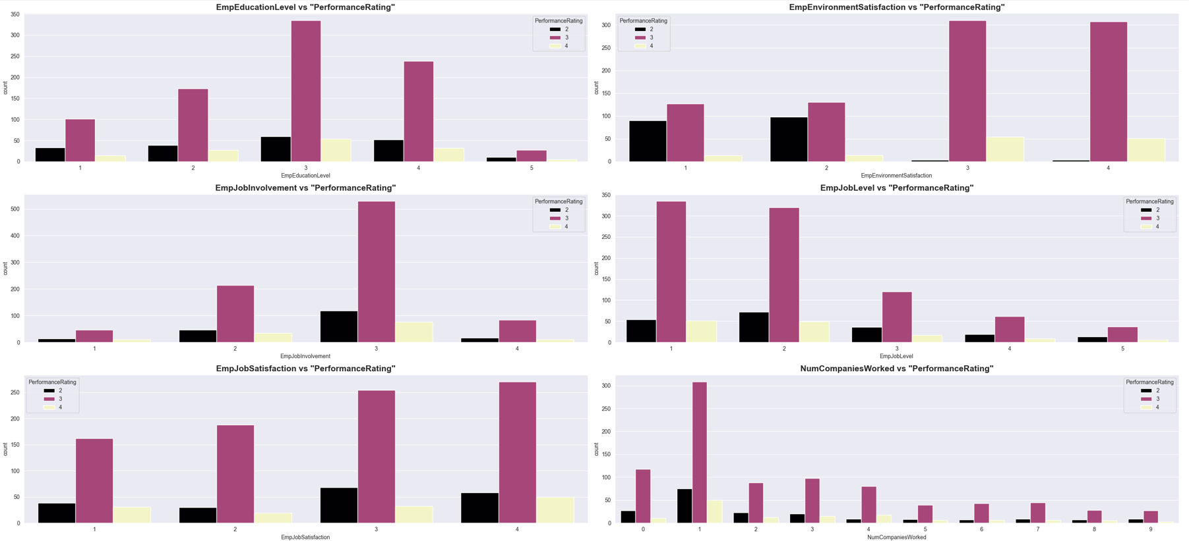

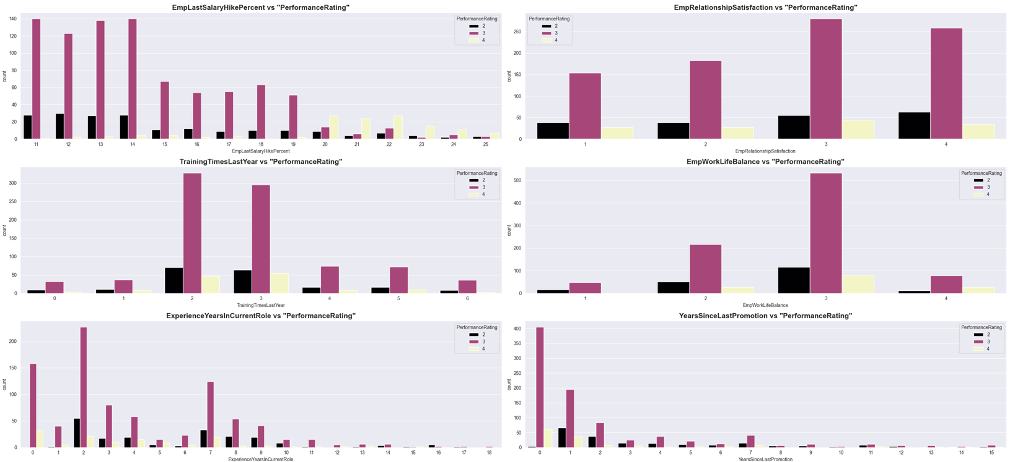

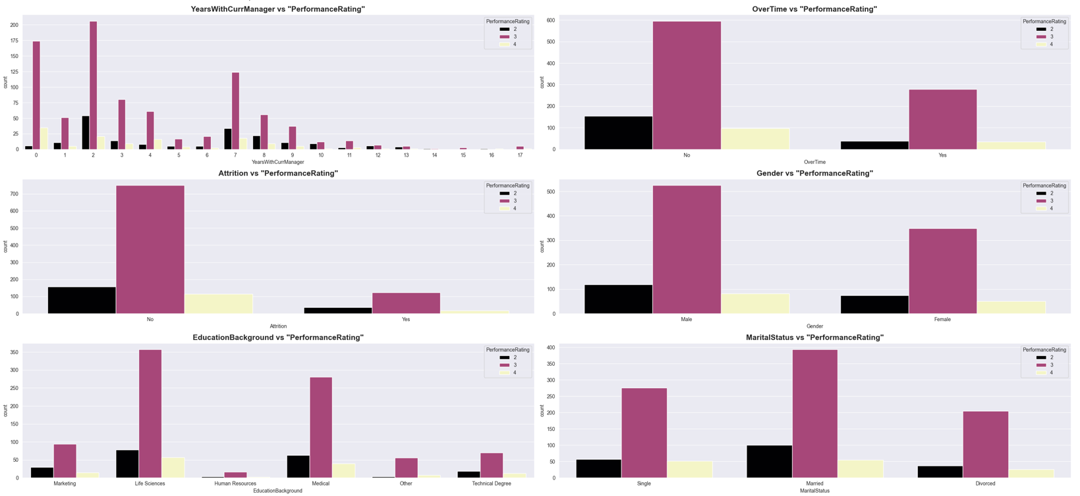

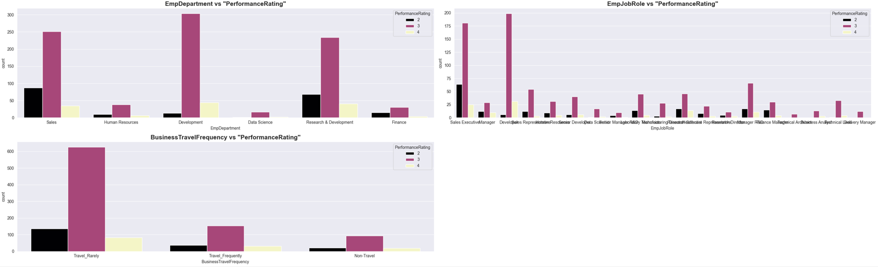

**Continuous features Vs target variable:**

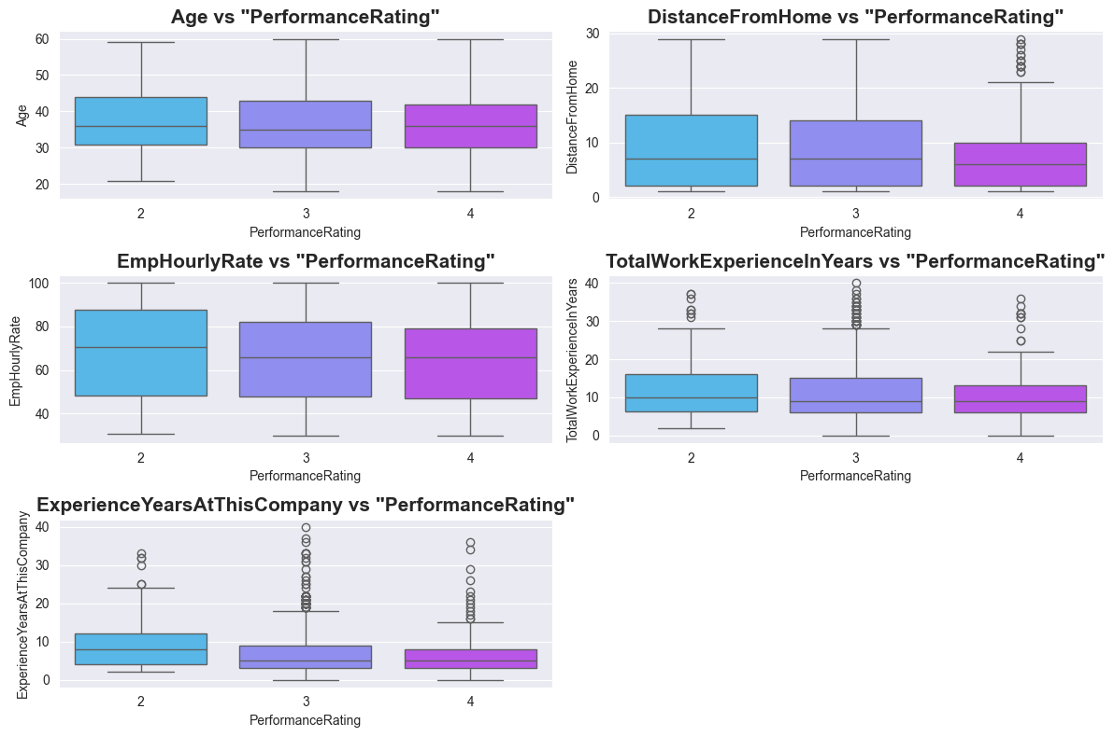

**Insights from bivariate analysis:**

* **EmpEducationLevel vs PerformanceRating**: Employees with higher education levels tend to have higher performance ratings, suggesting a positive correlation between education and performance.
* **EmpEnvironmentSatisfaction vs PerformanceRating:** Higher environment satisfaction correlates with higher performance ratings, indicating that a better work environment may enhance employee performance.
* **EmpJobInvolvement vs PerformanceRating**:Greater job involvement is associated with higher performance ratings, supporting the idea that more engaged employees perform better.
* **EmpJobLevel vs PerformanceRating:** Higher job levels generally see higher performance ratings, possibly reflecting more responsibilities and expectations being met.
* **NumCompaniesWorked vs PerformanceRating**: Employees who have worked with many companies do not necessarily have higher performance ratings, suggesting that frequent company changes might not impact performance significantly.
* **EmpLastSalaryHikePercent vs PerformanceRating:** Significant salary hikes are often given to employees with higher performance ratings, indicating a reward system based on performance.
* **TrainingTimesLastYear vs PerformanceRating**: More training does not clearly correlate with higher performance ratings, suggesting that the quality or relevance of training might be more important than quantity.
* **ExperienceYearsInCurrentRole vs PerformanceRating**: Longer tenure in the current role tends to correlate with higher performance ratings, possibly due to greater experience and familiarity with the role.
* **YearsWithCurrManager vs PerformanceRating**: Longer durations with the same manager are associated with higher performance ratings, which might reflect stable and effective managerial relationships.
* **Attrition vs PerformanceRating:** Employees who are not leaving the company generally have higher performance ratings, which could indicate satisfaction and commitment influencing performance.
* **Gender vs PerformanceRating:** The distribution of performance ratings across genders shows no significant bias, suggesting equitable performance evaluation processes.
* **EducationBackground vs PerformanceRating:** Employees from different educational backgrounds have varying performance ratings, with some backgrounds like 'Marketing' showing higher ratings, possibly reflecting the relevance of education to job roles.
* **MaritalStatus vs PerformanceRating**: Marital status shows varied performance ratings, with married employees slightly more likely to have higher ratings, potentially indicating stability.
* **EmpDepartment vs PerformanceRating**: Certain departments like 'Development' and 'Sales' have higher performance ratings, which might reflect department-specific performance criteria or work dynamics.
* **EmpJobRole vs PerformanceRating**: Specific job roles within departments show different performance ratings, highlighting the impact of job role expectations and responsibilities on performance.
* **BusinessTravelFrequency vs PerformanceRating**: Frequent travelers have varied performance ratings, suggesting that travel demands do not uniformly affect employee performance.

#### **DEPARTMENT WISE PERFORMANCE ANALYSIS:**

The study evaluates worker performance in many departments in order to spot any differences or patterns. When in case of Average performance, the below image

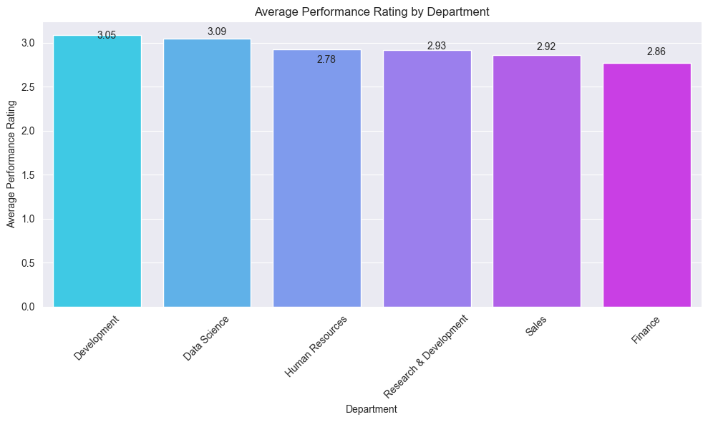

Implies **Data Science** group has high average performance.

**Insights:**

* High Performing Departments: Data Science has the highest average performance rating at 3.09, closely followed by Development at 3.05. This suggests that these departments are likely meeting or exceeding performance expectations, possibly due to effective management, skilled employees, or alignment with business goals.
* Mid-Range Performance: Human Resources, Research & Development, and Sales have performance ratings ranging from 2.78 to 2.93. These departments are performing adequately but might benefit from targeted improvements or interventions to boost their ratings closer to the leading departments.
* Lower Performance: Finance shows the lowest average performance rating at 2.86. This department might be facing challenges that could be impacting its performance, such as resource constraints, alignment with business objectives, or employee engagement issues.

When In case of Numbers comparison, the below image

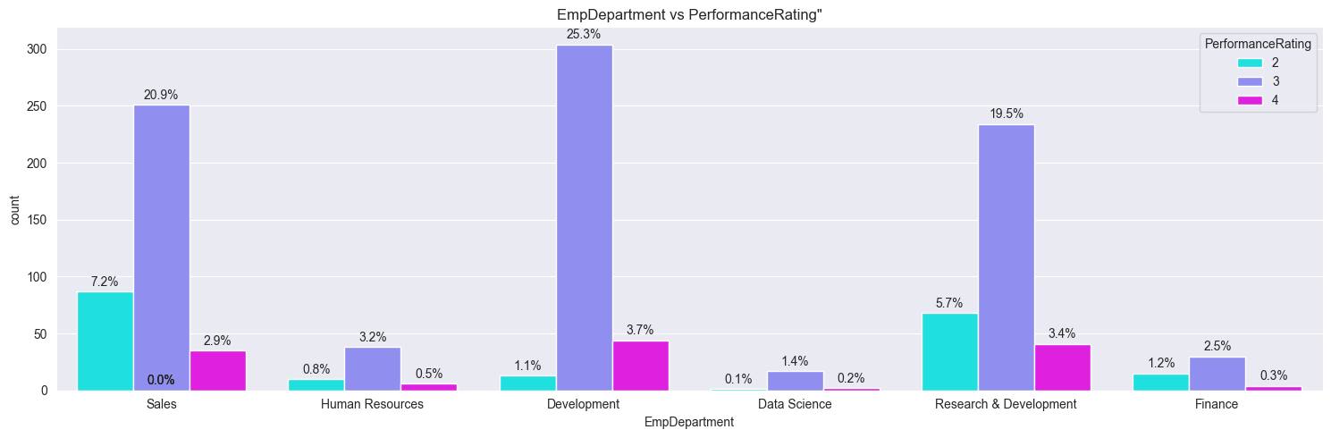

Implies Development Team or Department Has Highest Performance Rating.

**Insights:**

* In terms of number, the development department outnumbers the other departments.
* Employees in the development department score highly on performance evaluations, with a resounding 25% of ratings of 2.
* Therefore, high-performing personnel are found in departments like development, sales, and research & development.

### **FEATURE SELECTION/ FEATURE ENGINEERING:**

Feature selection techniques determine the relative importance of different features in predicting employee performance.

These techniques:

1. Ensure that visual analysis results are rigorously validated through appropriate methodologies and techniques.
2. Continuously monitor and evaluate analysis outcomes to ensure consistency and validity over time.

#### **THE TECHNIQUES USED IN THIS PROJECT ARE:**

#### **Correlation analysis:**

Pearson’s correlation coefficient is calculated to find out the correlation coefficients between two continuous variables.

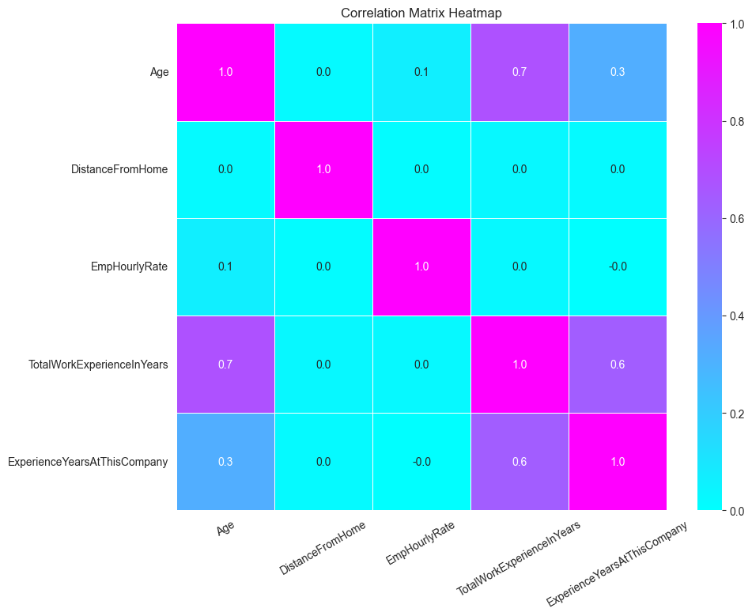

#### **TOP 3 FACTORS AFFECTING THE EMPLOYEE’S PERFORMANCE:**

From the data analysis and the feature engineering, there are some of the factors which proved crucial in predicting the employee’s performance.

**Among them the top three factors are as factors:**

1. EmpEnvironmentSatisfaction
2. EmpLastSalaryHikePercent
3. EmpDepartment_Development

**The visual analysis of these three factors are as follows:**

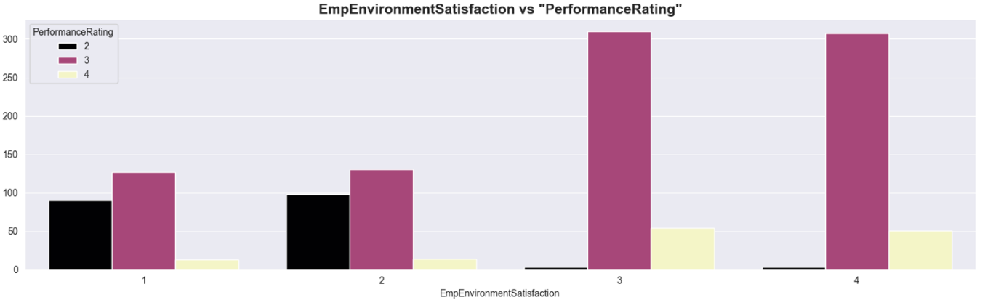

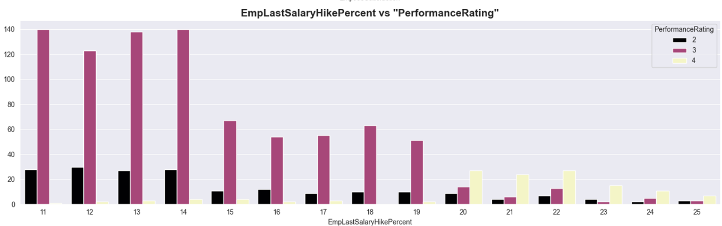

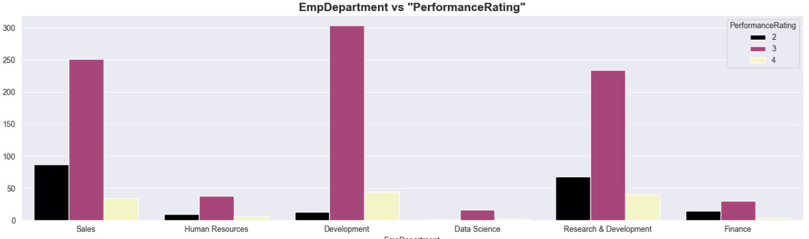

**Insights:**

### There exists a positive correlation between the aim and work environment satisfaction. Employee performance ratings rise in tandem with an increase in workplace happiness.

### There is a negative correlation between the feature "EmpLastSalaryHikePercent" and the target. For a defined range of wage raise percent of 11–14%, the performance rating is consistently extremely high. Thereafter, the performance falls off. Other elements that may contribute to this include the number of departments and their productivity, the scarcity of high-level posts, etc.

### In comparison to other departments, the employee's department of development has a high-performance rating.

## **PREPROCESSING TCHNIQUES USED**

### **ENCODING TECHNIQUES:**



These features are the categorical types to be encoded in the dataset.

### **OUTLIERS HANDLING:**



The above shows the number of outliers in the continuous independent features present in the dataset.

**Features with outliers are as follows:**

* TotalWorkExperienceInYears
* ExperienceYearsAtThisCompany

**Technique used to handle the outliers:**

**Interquartile method (IQR)** is used to find the outliers since these features are having skewed distribution.

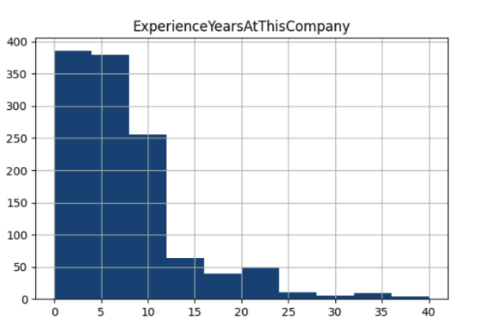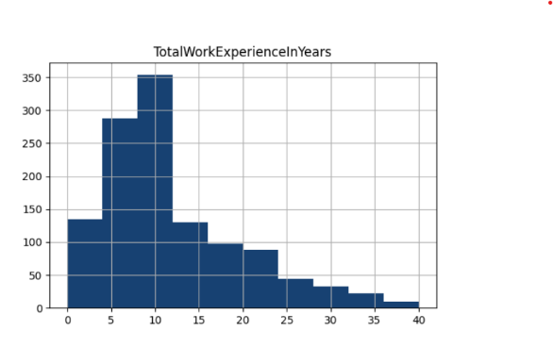

**The formulae used in the IQR method are as follows:**

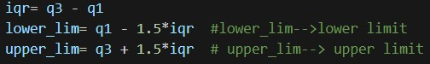

*# iqr🡪 inter-quartile range*

*# q1🡪 25th percentile*

*# q3🡪 75th percentile*

After finding the outliers, it would be replaced by the **median value** of the corresponding feature or column.

**The techniques utilized are as follows:**

* **For binary features:**
* Manual encoding is done, typically mapping is used ***(“No”🡪0, “Yes”🡪 1)***
* **For nominal features:**
* One-hot encoding is done which assigns binary value to a category with the rest of the categories as zero in a categorical feature.

### **SCALING:**

* There are two types of scaling in common practice.
* They are minmax scaler and the standard scalerMethods.
* However, in this project, **MinMaxScaler** is utilized from **scikit library**.

**MinMaxScaler:**

scales the features to a specified range, typically between 0 and 1.

**The continuous features that are scaled using MinMaxScaler are as follows:**

1. TotalWorkExperienceInYears
2. ExperienceYearsAtThisCompany

### **BALANCING THE DATASET:**

* Oversampling technique is used to balance the classes of the target variable.
* **SMOTE function** is used from **imblearn library**, which is one of the oversampling techniques.
* This algorithm helps to overcome the overfitting problem posed by random oversampling.

**Classes of the target of the training sample before and after oversampling:**



## **ALGORITHMS AND TRAINING METHODS USED**

### **Algorithms used in this project:**

* Decision Tree classifier
* Random Forest classifier
* Support Vector Machine
* Extreme Gradient Boosting

### **Model Training Methods:**

#### **DECISION TREE CLASSIFIER:**

* This algorithm works on the principle of if-else condition and make decisions by partitioning the input features into regions and assigning a class label to each region.
* It is preferred in this dataset due to its flexibility and easy model interpretability.
* Since the given dataset is medium-sized, decision tree can handle it well.

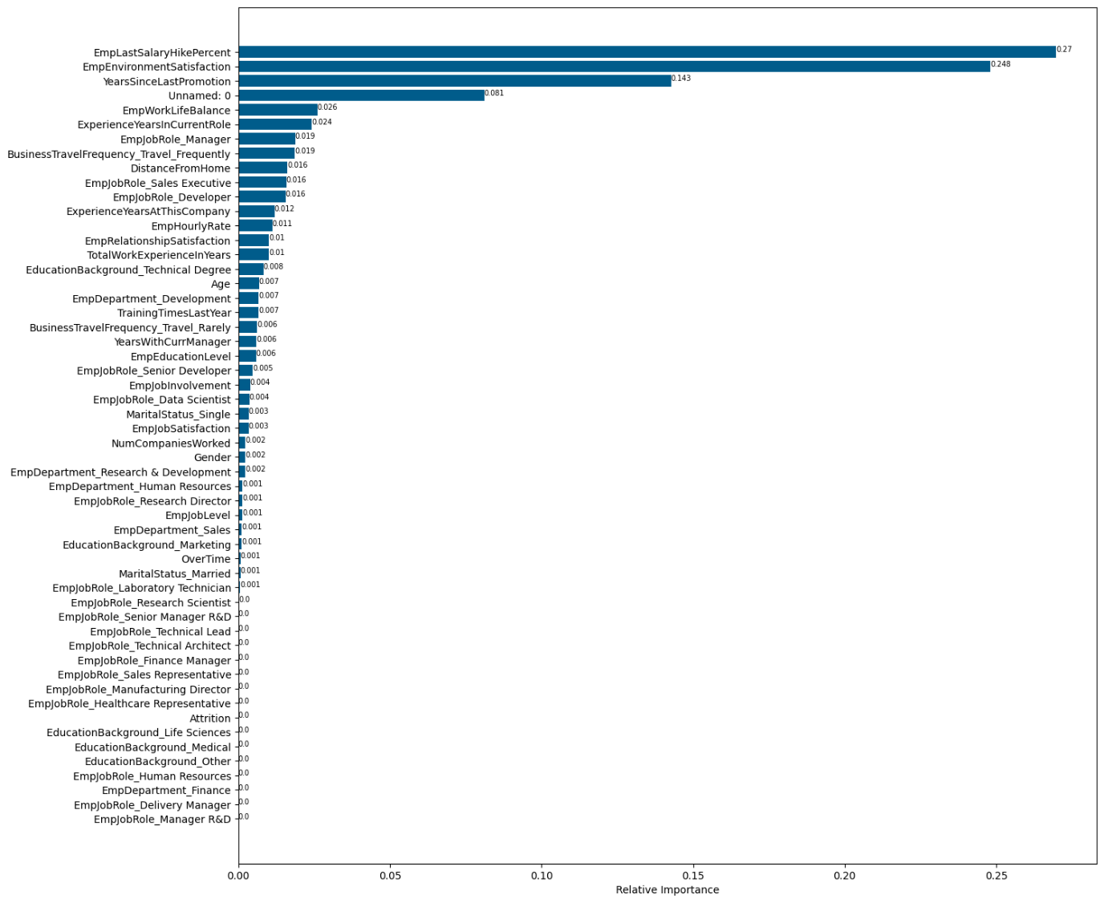

From the **feature importances** arrived at by this model, it is clear that the top three relevant features are:

* EmpLastSalaryHikePercent
* EmpEnvironmentSatisfaction
* YearsSinceLastPromotion

#### **TUNED DECISION TREE CLASSIFIER:**

This model refers to a decision tree algorithm that has been optimized for better performance.

The hyperparameters tuned in this model are as follows:

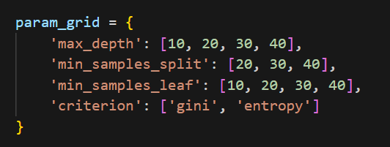

Cross validation technique used is **Grid Search CV** which exhaustively searches through a specified subset of hyperparameter combinations.

#### **RANDOM FOREST CLASSIFIER:**

* Random forest is an ensembling learning method that functions by constructing multiple decision trees during training and outputting the majority of the classes (classification) or the average prediction (regression) of the individual trees.
* This model is used here due to it’s ability to handle High-dimensional data, imbalanced datasets and capability of capturing complex relationships in the dataset.
* Moreover, it overcomes the overfitting issue of the decision tree model.

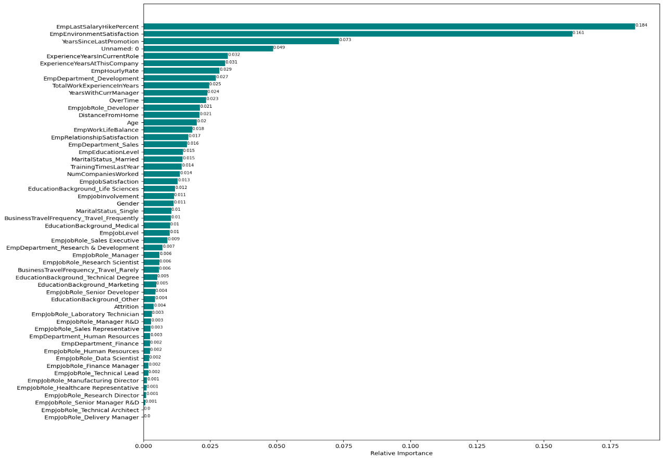

The feature importances in this model also gives the same top three features as the relevant features similar to that of the decision tree classifier.

#### **TUNED RANDOM FOREST CLASSIFIER:**

The hyperparameters tuned in this model are as follows:

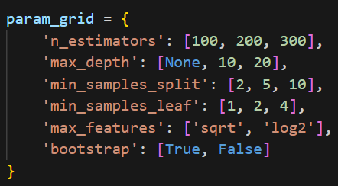

Cross validation technique used is **Grid Search CV** which exhaustively searches through a specified subset of hyperparameter combinations.

1. **SUPPORT VECTOR MACHINE:**

* A **Support Vector classifier** (SVC) works by finding the hyperplane that best separates the classes in the feature space.
* This model is trained in this project due to suitability to handle high-dimensional data.

1. **TUNED SUPPORT VECTOR CLASSFIER:**

The hyperparameters tuned in this model are as follows:

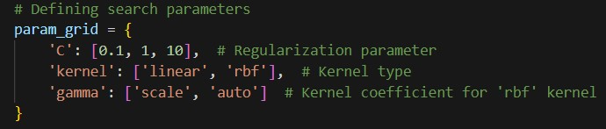

Cross validation technique used is **Grid Search CV** which exhaustively searches through a specified subset of hyperparameter combinations.

1. **TUNED XG BOOSTING:**

* XGBoost (eXtreme Gradient Boosting) is an efficient implementation of gradient boosting which builds a series of weak learners, with each new learner correcting errors made by the previous ones.
* This contains in-built regularization techniques and pruning to prevent overfitting and control the model complexity.
* This model is highly scalable due to parallelization and distributed computing.

